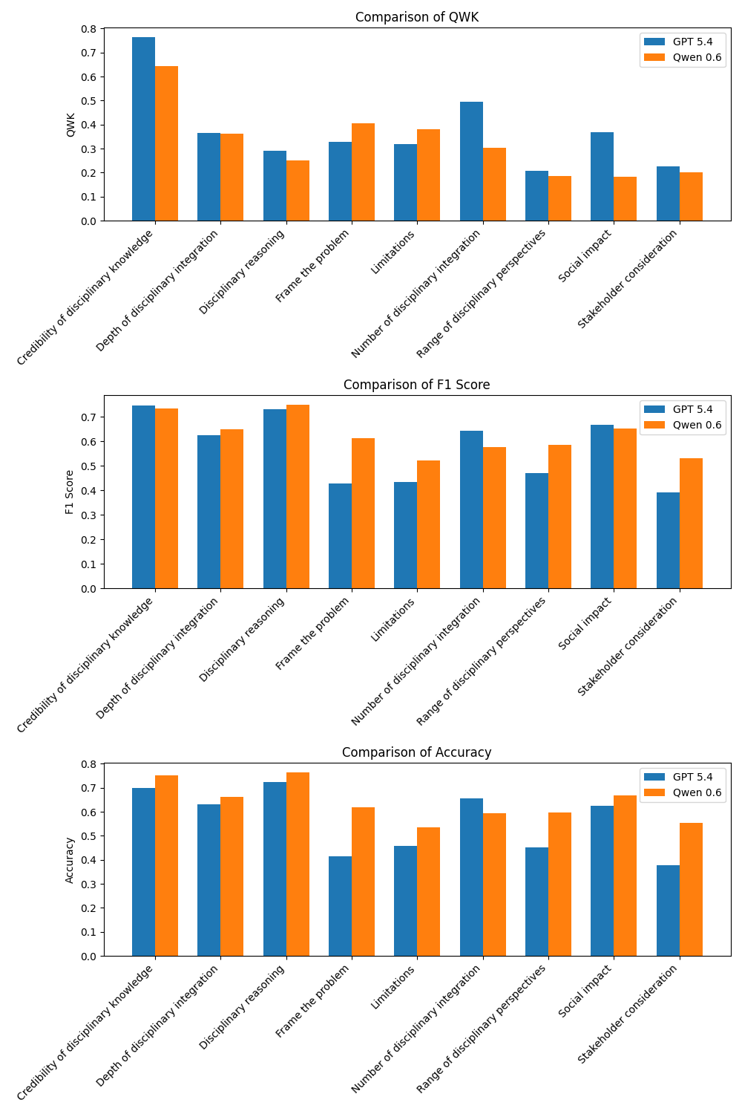

The trained Qwen 0.6 model generally outperforms the generic GPT 5.4 model in terms of Accuracy and F1 Score across most of the 9 evaluation dimensions, though GPT 5.4 maintains a notable advantage in Quadratic Weighted Kappa (QWK) for specific areas like credibility and integration.
(Note: The GPT 5.4 scores are drawn from the complete "Run2" sheet in GPTQWKScores.xlsx, while the Qwen 0.6 scores are averaged across the 5 evaluation folds found in 400essays9dimensionsQWK.xlsx.)
Key Takeaways
- F1 Score and Accuracy (Qwen Dominates): The trained Qwen 0.6 model shows significant improvements in baseline correctness and consistency. It outperforms GPT 5.4 in Accuracy across 8 of the 9 dimensions (all except Number of disciplinary integration). The performance gap is especially wide for Frame the problem (+20.4% Accuracy, +18.4% F1) and Stakeholder consideration (+17.5% Accuracy, +14.0% F1).
- QWK (Mixed Results): QWK measures the agreement beyond chance, heavily penalizing large discrepancies. Here, the generic GPT 5.4 model performs better in several critical dimensions. It holds a strong lead in Credibility of disciplinary knowledge (0.765 vs. 0.642), Number of disciplinary integration (0.495 vs. 0.304), and Social impact (0.369 vs. 0.183).
- Closest Alignments: Both models performed almost identically on the Depth of disciplinary integration dimension when looking at QWK (0.366 for GPT vs 0.363 for Qwen), though Qwen still edged out slightly better F1 and Accuracy scores.

